University of Central Punjab
Faculty of Information Technology and Computer Science

Course Title: Software Construction & Development
Course Code: SESD3242

Assignment 3

Name | ID | Contribution in the assignment (Specifically mention the part which you have done)
HIRA KHAN | 0254
AIMAN | 0237

CLO | At the end of the course the students will be able to: | BT Level* | PLO
CLO2 | Apply construction techniques to write a clean and maintainable code that meets industry standards and best practices. | C2 | 2

Deadline: 19-May-26 Total Marks= 50

Instructions:
- Late submission will cause 20% deduction. No submission after 2 Days.
- This assignment is a group assignment. 2 members in each group. Individual submissions will not be accepted.
- ASSIGNMENT SHOULD BE PROPERLY TYPED.
- Attach this title page to your submission. (5 marks)
- Upload it on the portal on 19-May-26_at 11:55pm
- Plagiarism is seriously your own choice.
- Evaluation will be viva-based. Viva date and time will be announced later.

Code:
import java.awt.*;
import java.awt.event.*;
import java.time.LocalDate;
import java.time.format.DateTimeParseException;
import javax.swing.*;
import javax.swing.border.EmptyBorder;
import javax.swing.border.LineBorder;
// Custom Exceptions
class EmptyFieldException extends Exception {
public EmptyFieldException(String message) {
super(message);
}
}
class InvalidRollNumberException extends Exception {
public InvalidRollNumberException(String message) {
super(message);
}
}
class InvalidDateException extends Exception {
public InvalidDateException(String message) {
super(message);
}
}
class NullSelectionException extends Exception {
public NullSelectionException(String message) {
super(message);
}
}
public class Frame extends JFrame implements ActionListener {
private static final long serialVersionUID = 1L;
private JPanel contentPane;
// Labels
JLabel lblTitle, lblName, lblRoll, lblBook, lblCategory;
JLabel lblIssueDate, lblReturnDate, lblRemarks, lblType;
// Text Fields
JTextField txtName, txtRoll, txtBook, txtIssueDate, txtReturnDate;
// Text Area
JTextArea txtRemarks;
// Combo Box
JComboBox<String> comboCategory;
// Radio Buttons
JRadioButton rbNew, rbOld;
ButtonGroup group;
// Buttons
JButton btnIssue, btnReset, btnExit;
public static void main(String[] args) {
EventQueue.invokeLater(new Runnable() {
public void run() {
try {
Frame frame = new Frame();
frame.setVisible(true);
} catch (Exception e) {
e.printStackTrace();
}
}
});
}
public Frame() {
setTitle("Library Management System");
setDefaultCloseOperation(JFrame.EXIT_ON_CLOSE);
setBounds(100, 100, 780, 720);
setLocationRelativeTo(null);
contentPane = new JPanel();
contentPane.setBackground(new Color(230, 240, 255));
contentPane.setBorder(new EmptyBorder(15, 15, 15, 15));
contentPane.setLayout(null);
setContentPane(contentPane);
// Main Panel
JPanel panel = new JPanel();
panel.setBounds(90, 30, 580, 610);
panel.setLayout(null);
panel.setBackground(Color.WHITE);
panel.setBorder(new LineBorder(new Color(180, 180, 180), 2, true));
contentPane.add(panel);
// Title
lblTitle = new JLabel("Library Management System");
lblTitle.setFont(new Font("Segoe UI", Font.BOLD, 28));
lblTitle.setForeground(new Color(52, 73, 94));
lblTitle.setBounds(100, 20, 400, 40);
panel.add(lblTitle);
Font labelFont = new Font("Segoe UI", Font.PLAIN, 16);
// Student Name
lblName = new JLabel("Student Name");
lblName.setFont(labelFont);
lblName.setBounds(40, 90, 150, 30);
panel.add(lblName);
txtName = new JTextField();
txtName.setBounds(230, 90, 290, 35);
panel.add(txtName);
// Roll Number
lblRoll = new JLabel("Roll Number");
lblRoll.setFont(labelFont);
lblRoll.setBounds(40, 140, 150, 30);
panel.add(lblRoll);
txtRoll = new JTextField();
txtRoll.setBounds(230, 140, 290, 35);
panel.add(txtRoll);
// Book Title
lblBook = new JLabel("Book Title");
lblBook.setFont(labelFont);
lblBook.setBounds(40, 190, 150, 30);
panel.add(lblBook);
txtBook = new JTextField();
txtBook.setBounds(230, 190, 290, 35);
panel.add(txtBook);
// Category
lblCategory = new JLabel("Book Category");
lblCategory.setFont(labelFont);
lblCategory.setBounds(40, 240, 150, 30);
panel.add(lblCategory);
String categories[] = {
"Select Category",
"Programming",
"AI",
"Databases",
"Networking"
};
comboCategory = new JComboBox<>(categories);
comboCategory.setBounds(230, 240, 290, 35);
panel.add(comboCategory);
// Book Type
lblType = new JLabel("Book Type");
lblType.setFont(labelFont);
lblType.setBounds(40, 290, 150, 30);
panel.add(lblType);
rbNew = new JRadioButton("New Edition");
rbNew.setBounds(230, 290, 130, 30);
rbNew.setBackground(Color.WHITE);
panel.add(rbNew);
rbOld = new JRadioButton("Old Edition");
rbOld.setBounds(380, 290, 130, 30);
rbOld.setBackground(Color.WHITE);
panel.add(rbOld);
group = new ButtonGroup();
group.add(rbNew);
group.add(rbOld);
// Issue Date
lblIssueDate = new JLabel("Issue Date");
lblIssueDate.setFont(labelFont);
lblIssueDate.setBounds(40, 340, 150, 30);
panel.add(lblIssueDate);
txtIssueDate = new JTextField();
txtIssueDate.setBounds(230, 340, 290, 35);
txtIssueDate.setToolTipText("Format: YYYY-MM-DD");
panel.add(txtIssueDate);
// Return Date
lblReturnDate = new JLabel("Return Date");
lblReturnDate.setFont(labelFont);
lblReturnDate.setBounds(40, 390, 150, 30);
panel.add(lblReturnDate);
txtReturnDate = new JTextField();
txtReturnDate.setBounds(230, 390, 290, 35);
txtReturnDate.setToolTipText("Format: YYYY-MM-DD");
panel.add(txtReturnDate);
// Remarks
lblRemarks = new JLabel("Remarks");
lblRemarks.setFont(labelFont);
lblRemarks.setBounds(40, 440, 150, 30);
panel.add(lblRemarks);
txtRemarks = new JTextArea();
JScrollPane scrollPane = new JScrollPane(txtRemarks);
scrollPane.setBounds(230, 440, 290, 70);
panel.add(scrollPane);
// Issue Button
btnIssue = new JButton("Issue Book");
btnIssue.setBounds(50, 540, 140, 40);
btnIssue.setBackground(new Color(39, 174, 96));
btnIssue.setForeground(Color.WHITE);
btnIssue.setFocusPainted(false);
btnIssue.addActionListener(this);
panel.add(btnIssue);
// Reset Button
btnReset = new JButton("Reset");
btnReset.setBounds(230, 540, 120, 40);
btnReset.setBackground(new Color(241, 196, 15));
btnReset.setForeground(Color.WHITE);
btnReset.setFocusPainted(false);
btnReset.addActionListener(this);
panel.add(btnReset);
// Exit Button
btnExit = new JButton("Exit");
btnExit.setBounds(400, 540, 120, 40);
btnExit.setBackground(new Color(231, 76, 60));
btnExit.setForeground(Color.WHITE);
btnExit.setFocusPainted(false);
btnExit.addActionListener(this);
panel.add(btnExit);
}
@Override
public void actionPerformed(ActionEvent e) {
// ISSUE BUTTON
if (e.getSource() == btnIssue) {
try {
// Empty Field Exception
if (txtName.getText().trim().isEmpty()
|| txtRoll.getText().trim().isEmpty()
|| txtBook.getText().trim().isEmpty()
|| txtIssueDate.getText().trim().isEmpty()
|| txtReturnDate.getText().trim().isEmpty()) {
throw new EmptyFieldException(
"Required fields cannot be empty!");
}
// Roll Number Validation
String roll = txtRoll.getText();
if (!roll.matches("\\d+")) {
throw new InvalidRollNumberException(
"Roll Number must contain only digits!");
}
// NumberFormatException
int rollNo = Integer.parseInt(roll);
// Category Validation
if (comboCategory.getSelectedIndex() == 0) {
throw new NullSelectionException(
"Please select a book category!");
}
// Radio Button Validation
if (!rbNew.isSelected() && !rbOld.isSelected()) {
throw new NullSelectionException(
"Please select a book type!");
}
// Date Validation
LocalDate issueDate = LocalDate.parse(txtIssueDate.getText());
LocalDate returnDate = LocalDate.parse(txtReturnDate.getText());
if (returnDate.isBefore(issueDate)) {
throw new InvalidDateException(
"Return date cannot be earlier than issue date!");
}
String edition = "";
if (rbNew.isSelected()) {
edition = "New Edition";
}
else {
edition = "Old Edition";
}
JOptionPane.showMessageDialog(this,
"Book Issued Successfully!\n\n"
+ "Student Name: "
+ txtName.getText()
+ "\nRoll Number: "
+ rollNo
+ "\nBook Title: "
+ txtBook.getText()
+ "\nCategory: "
+ comboCategory.getSelectedItem()
+ "\nBook Type: "
+ edition
+ "\nIssue Date: "
+ txtIssueDate.getText()
+ "\nReturn Date: "
+ txtReturnDate.getText()
+ "\nRemarks: "
+ txtRemarks.getText());
}
catch (EmptyFieldException ex) {
JOptionPane.showMessageDialog(this,
ex.getMessage(),
"Empty Field Error",
JOptionPane.ERROR_MESSAGE);
}
catch (InvalidRollNumberException ex) {
JOptionPane.showMessageDialog(this,
ex.getMessage(),
"Invalid Roll Number",
JOptionPane.ERROR_MESSAGE);
}
catch (InvalidDateException ex) {
JOptionPane.showMessageDialog(this,
ex.getMessage(),
"Date Error",
JOptionPane.ERROR_MESSAGE);
}
catch (NullSelectionException ex) {
JOptionPane.showMessageDialog(this,
ex.getMessage(),
"Selection Error",
JOptionPane.ERROR_MESSAGE);
}
catch (NumberFormatException ex) {
JOptionPane.showMessageDialog(this,
"Roll Number must be numeric!",
"Number Format Error",
JOptionPane.ERROR_MESSAGE);
}
catch (DateTimeParseException ex) {
JOptionPane.showMessageDialog(this,
"Invalid Date Format! Use YYYY-MM-DD",
"Date Format Error",
JOptionPane.ERROR_MESSAGE);
}
finally {
JOptionPane.showMessageDialog(this,
"Operation Completed!");
}
}
// RESET BUTTON
if (e.getSource() == btnReset) {
txtName.setText("");
txtRoll.setText("");
txtBook.setText("");
txtIssueDate.setText("");
txtReturnDate.setText("");
txtRemarks.setText("");
group.clearSelection();
comboCategory.setSelectedIndex(0);
}
// EXIT BUTTON
if (e.getSource() == btnExit) {
System.exit(0);
}
}
}
Exceptions Implemented:
- EmptyFieldException
→ When required fields are empty
- InvalidRollNumberException
→ When roll number contains alphabets
- InvalidDateException
→ When return date is earlier than issue date
- NullSelectionException
→ When category or radio button is not selected
- NumberFormatException
→ When numeric conversion fails
- DateTimeParseException
→ When wrong date format is entered
- finally block
→ Displays “Operation Completed!”

ScreenShots:
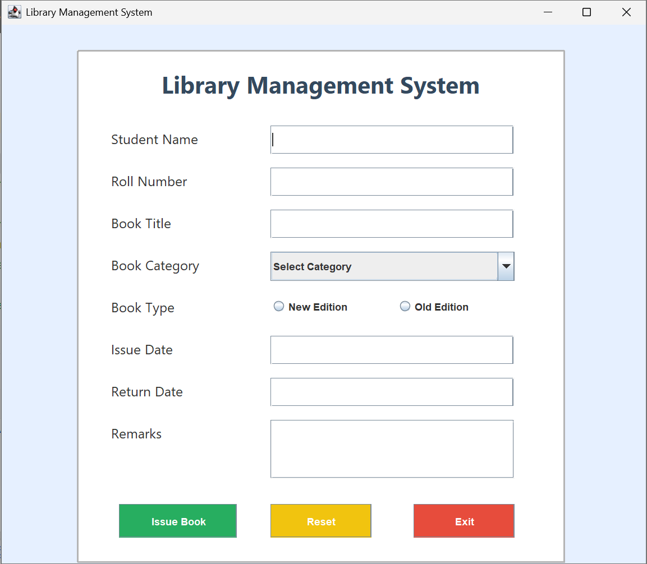
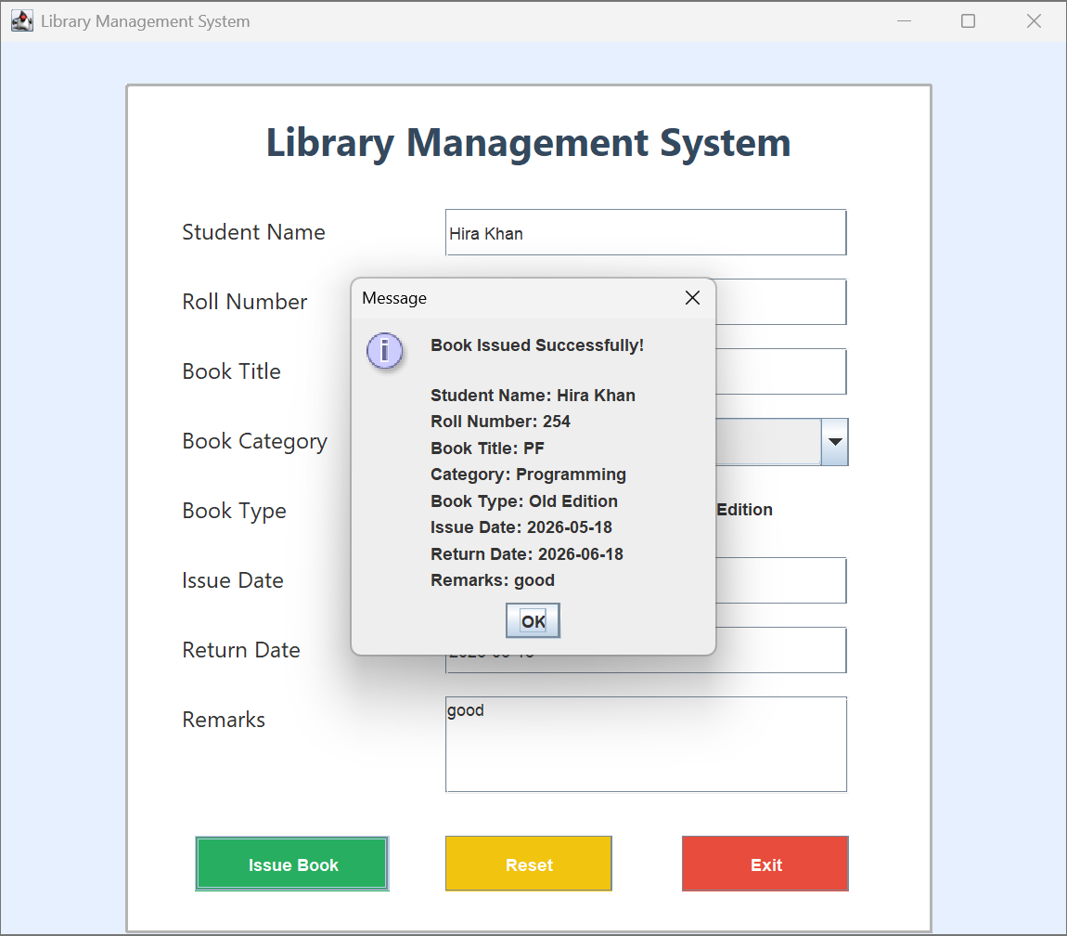
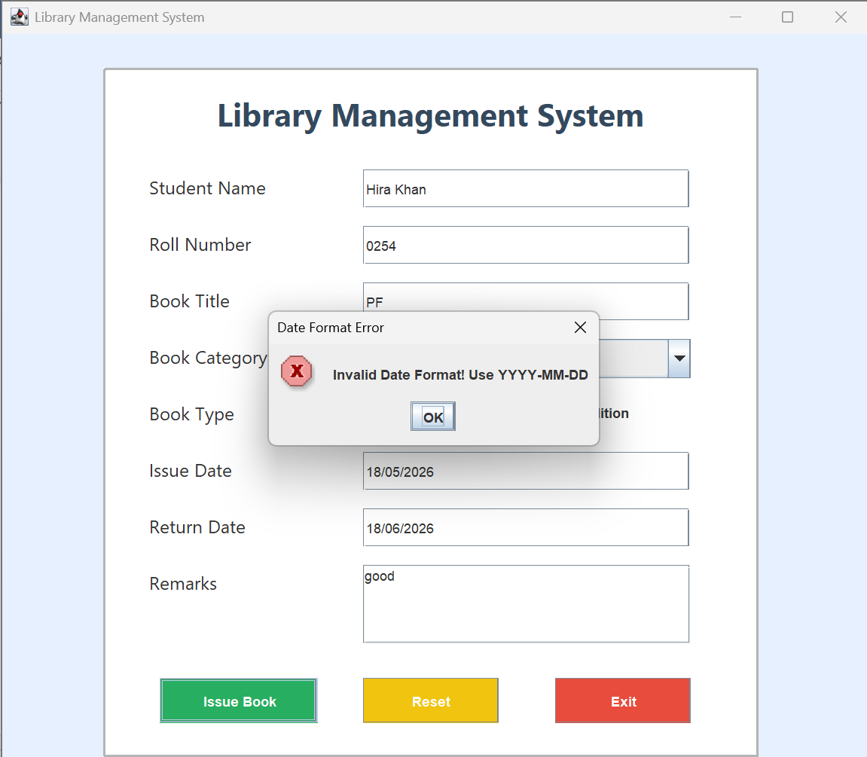
GitHub respository link:
https://github.com/HiraKhan13/Library-Management-System

